

Diverse WA Training Portal

Multi-Factor Authentication Step by Step User Guide

Contents

1 Purpose 3
2 Scope 3
2.1 Document Control 3
2.2 Endorsement & Approvals 3
3 Sign Up Using Your Email Address 4
4 Using Your Mobile Phone for MFA 10
5 MFA via Email 14
6 MFA Using an Authenticator App 18
7 Still need support? 21

1 Purpose

The purpose of this guide is to help users access Diverse WA Training Portal using Mult-Factor Authentication (MFA). Users can choose from the following authentication options:

- Receiving a code via mobile phone
- Receiving a code via email
- Generating a code using a Multi-factor Authenticator App on a mobile phone

2 Scope

This user guide applies to all current and new users of Diverse WA Training Portal, managed by the Department of Creative Industries, Tourism and Sport through the Office of Multicultural Interests. It is designed to assist users in accessing the portal for the first time using Multi-Factor Authentication (MFA).

2.1 Document Control

Version | Date | Name & Position / Committee | Status / Notes
0.1 | 20/08/2025 | Syed Sajid Husain, ICT Change Manager | First Draft
0.2 | 18/09/2025 | Syed Sajid Husain, ICT Change Manager | Further revision and update

2.2 Endorsement & Approvals

Name | Position | Endorse/Approve | Signature | Date

3 Sign Up Using Your Email Address

All users – new or existing, please sign up using your email address. This step is only required when accessing the portal for the first time using Multi-Factor Authentication (MFA).
For any subsequent access, please sign in directly.

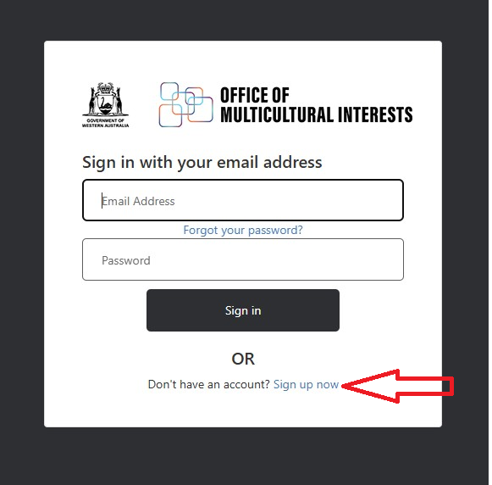

Enter your email address and click “Send verification code” to proceed.

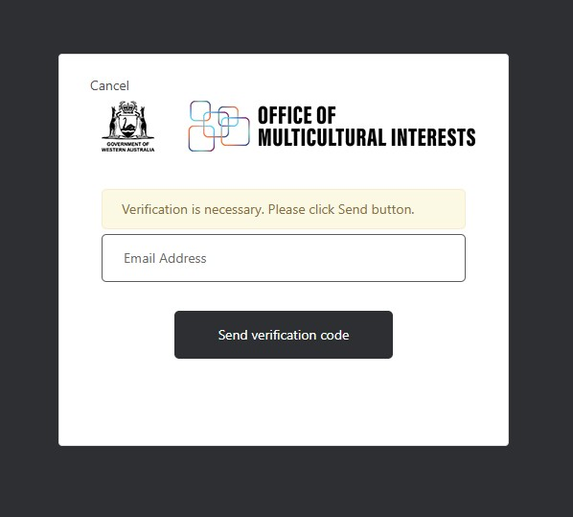

You will receive a verification code at your email address. Please enter the code into the verification box and click "Verify code" to proceed.

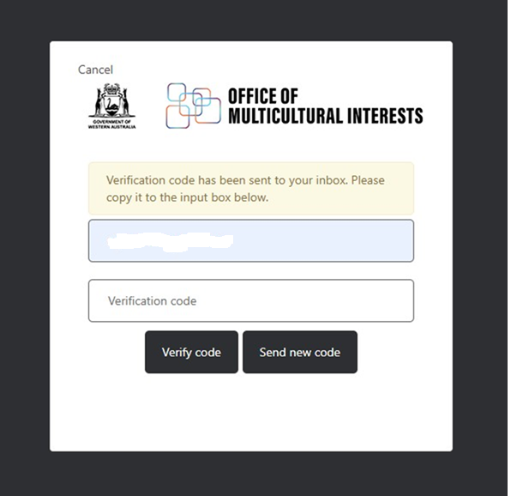

Your email address has been successfully verified. Please click "Continue" to proceed.

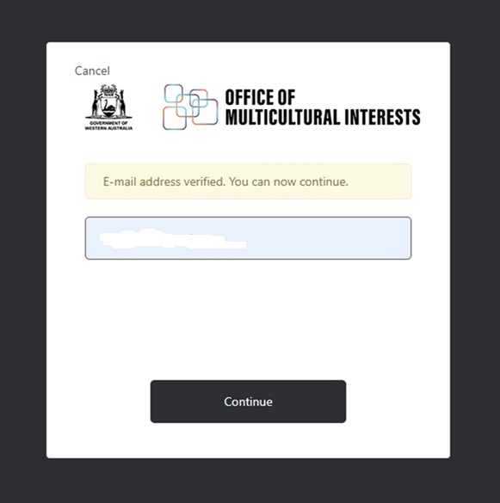

Please enter a new password, your given name, and surname, then click "Create" to complete the setup.

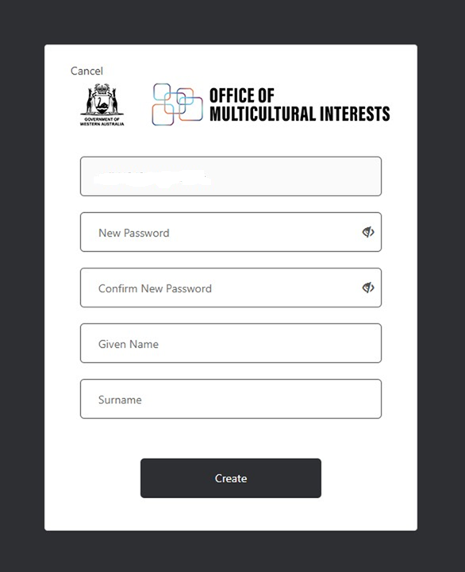

You will see the below screen with Multi-Factor Authentication (MFA) options. You can choose your preferred method: Phone, Email, or Authenticator. Select the option that works best for you.

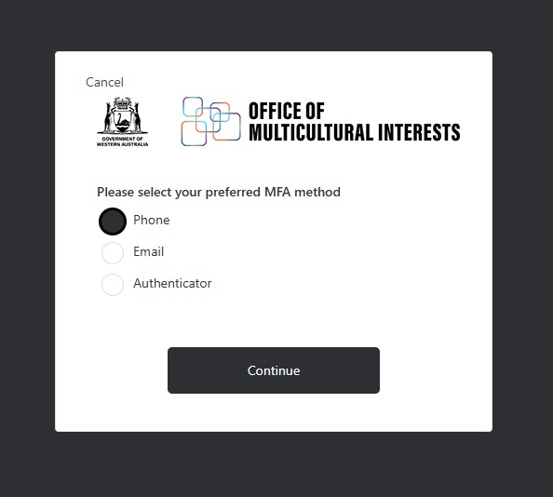

4 Using Your Mobile Phone for MFA

If you prefer to use your phone, please select the "Phone" option as shown below and click "Continue" to proceed.

You will have the option to either receive a code or a phone call on your mobile device. If you choose to receive a code, please enter your phone number in the box below and click "Send Code."

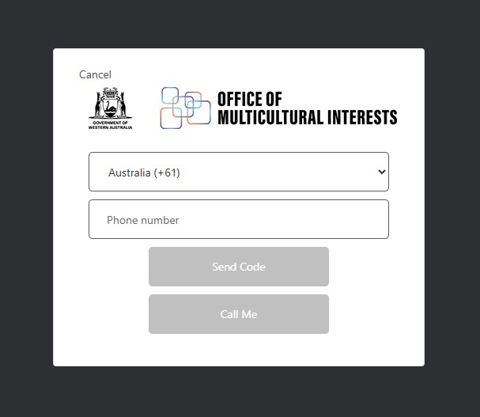

A 6-digit verification code will be sent to your mobile phone. Please enter the code in the box below and click “Verify Code”. Once verified, you’ll be successfully logged in.

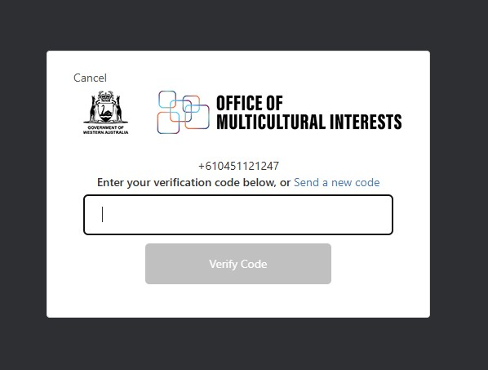

If you’d prefer to verify your identity by phone call, click “Call Me”. Microsoft will call you and ask you to press a specific key. Once you press the key, you’ll be logged in automatically.

5 MFA via Email

If you prefer to verify using your email address, please select “Email” and click “Continue”.

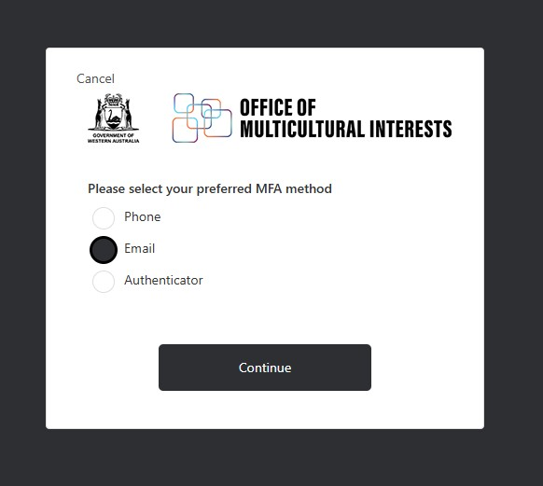

Please enter your email address in the box below, then click “Send verification code”.

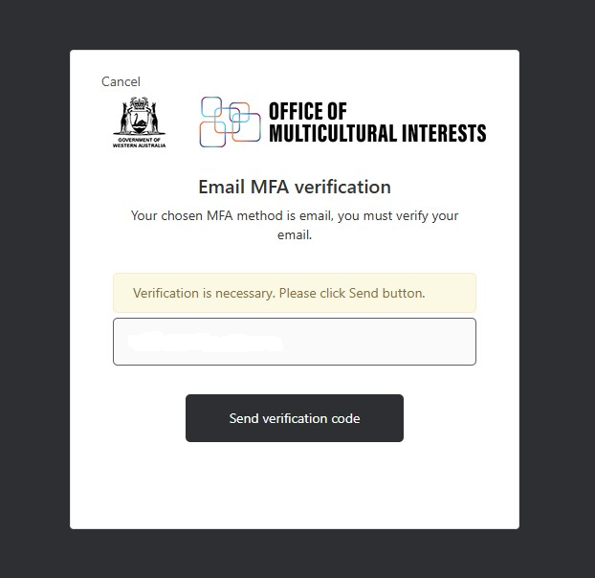

You will receive a verification code in your inbox.
Copy the code, paste it into the Verification code box below, and click “Verify Code” to continue.

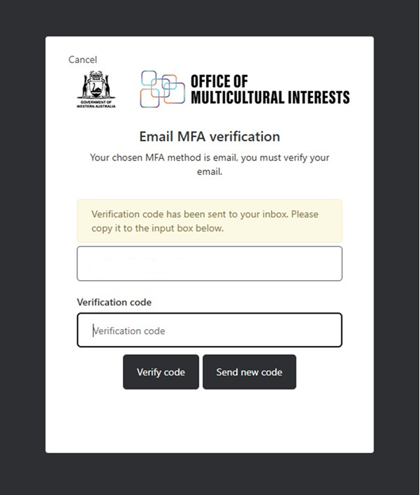

Once your email address is verified, click “Continue” to log in to the portal.

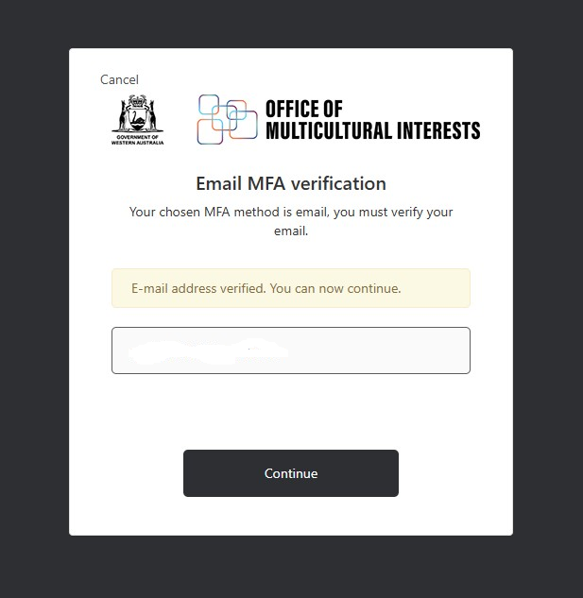

6 MFA Using an Authenticator App

If you prefer to access using the Microsoft Authenticator app, please select “Authenticator” from the options below and click “Continue”.

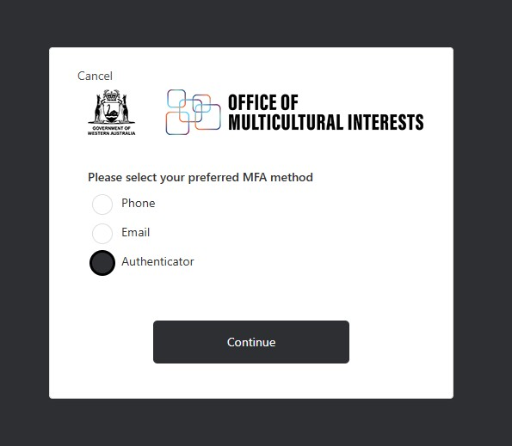

If you don’t have the Microsoft Authenticator app on your mobile device, please download it from the App Store (iOS) or Google Play (Android).
Once installed, open the app and scan the QR code shown below. This will add the Diverse WA Training Portal information with your email address to your Authenticator app.
After scanning the QR code, click “Continue” to proceed.

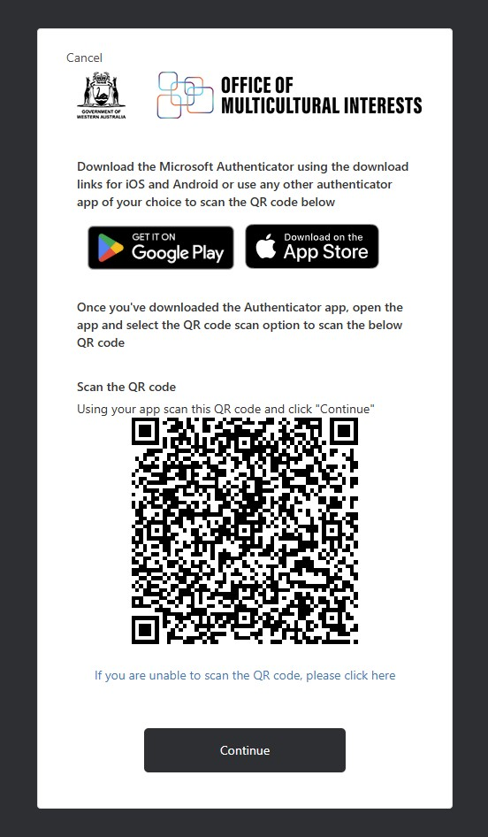

If you’re unable to scan the QR code, click the link “If you are unable to scan the QR code, please click here.”
You’ll be provided with an account name (your email address) and a secret key.
To add your account manually in the Microsoft Authenticator app:
- Open the app and tap the ‘+’ icon at the top.
- Select Other account (e.g., Gmail, Yahoo).
- Tap Enter code manually.
- Enter the account name and the secret key.
- Tap Finish.
The Diverse WA Training Portal information with your email address will be added to your Authenticator app.
Once done, click “Continue” to proceed.

The following screen will pop up asking you to enter the verification code from your authenticator app.

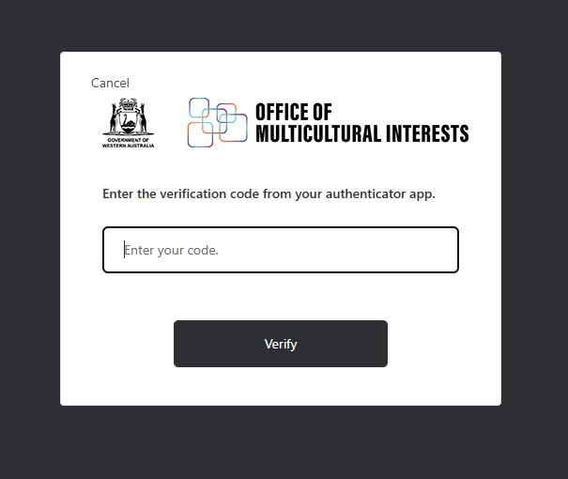

Select Diverse WA Training Portal information from the Microsoft Authenticator app on your mobile device. A verification code will pop up.
Enter the code in the box below and click “Verify”. Once the code is verified, you’ll be successfully logged in.

7 Still need support?

If you continue to experience issues accessing the Diverse WA Training Portal, please contact diversewa@omi.wa.gov.au for assistance.

